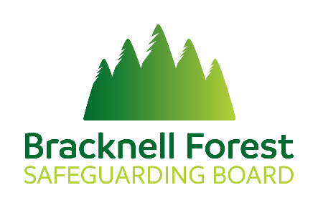

The voice of adults/child – collecting peoples’ experiences of safeguarding from existing community engagement processes

Hearing the voice of people and communities is an essential aspect of safeguarding boards’ work. The Communication, Prevention & Engagement (CEP) subgroup has previously agreed that in addressing this, it is important to start by considering community engagement information already being collected by partners through their existing and day to day activities. This may include feedback on services, surveys, case studies or feedback on people’s experiences of safeguarding.

Name of organisation:
Name of contact:
- Can you provide us with any issues/trends that you are picking up regarding people’s experiences of safeguarding?

- Do you have any forums that we could link with to gain a better insight of people’s lived experiences of safeguarding?

